**AWS Exercises**

**Note:** The following are meant to be rough guidelines on the steps to complete each setup. They are not made to be easy-to-follow tutorials so that the user or any future user will take it upon themselves to revise missing concepts at any given step leading up to the solution. This document might later be developed into a full-breadth tutorial with guided screenshots for each step.

1. **Bastion instance setup**

**Note:** This setup connects to a private VPC subnet through a Bastion and pings Google from the private subnet

- Create Public and Private VPC

- Create NAT/Bastion instance in public subnet (Linux)

- Create instance in private subnet (Ubuntu)

- Configure Ubuntu route table default route to Bastion instance

- Configure Bastion security group to allow incoming traffic from private subnet

- Make sure public and private security groups allow SSH connection

- Save Bastion security key pair in Pageant (we are using the same pair for the ubuntu private instance in this example)

- Connect to Bastion instance with Putty and turn on Agent Forwarding in Auth settings

- From Bastion instance, ssh ubuntu@<Private Ubuntu IP>

- After successfully connecting to private instance, ping [www.google.com](http://www.google.com)

1. **RStudio instance setup**

- Create Instance from Amazon RStudio Ubuntu AMI

- Edit Security Groups to add http inbound rule

- Launch instance

- Connect to instance public ip from local browser to reach RStudio landing page

1. **Web Server instance**

- Create Amazo Linux instance

- Configure Security Groups to allow http inbound

- Launch instance

- Connect to instance

- Configure ec2 user prvileges

- Create sample index.php file in var/www/html

- Connect to instance public ip from local browser

1. **ELB connected to 2 private instances setup**

- Create VPC with 2 public and 2 private subnets

- Create 2 private instances (one in each availability zone)

- Create ELB and assign it to the public subnets (so it is internet-facing)

- Assign the private instances to the ELB

**Architecture Diagram:**

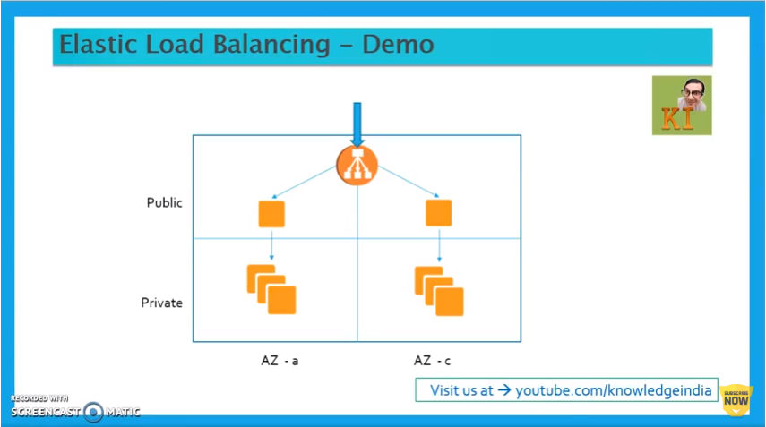

1. **Start-stop EC2 instance with Lambda function**

- Create policy with permissions on aws EC2

- Create role linked to the policy

- Create lambda function that stops running EC2 instance (could be based on specific instance id)

- Create lambda function that starts stopped EC2 instance (based on intance id)